Strengthening Role of Nitrogen PM_{2.5} composition in the PRD Region

Abstract

This study aims to investigate the correlation between nitrogen deposition change and PM2.5 composition in the Pearl River Delta, with consideration of changes from various emission sources. Observation data used are from the NNDMN network, MME observation sites, and ground observation data from Prof. Jianzhen Yu. From 2010 to 2020, atmospheric NO₂ declined by ~0.21 μg N m⁻³ yr⁻¹, ammonia (NH₃) and particulate ammonium (NH₄⁺) concentrations increased, driven by unregulated agricultural and non-agricultural emissions. Consequently, the reduced nitrogen (NHₓ) fraction in total nitrogen deposition surged from 33% to 50%. This shift has sustained nitrate aerosol formation despite NOₓ reductions, altering PM2.5 composition where sulfate now declines twice as fast as nitrate. Despite the great disagreement between the observation data and the modeled quantity, the model did show clear seasonal variations and annual trend.

Introduction

Fine particulate matter (PM_{2.5}) continues to be the dominant air-quality concerns in China despite major emission reductions in the past years (Xiao et al, 2020). Studies had proved that particulate matter is related to premature deaths, cardiovascular diseases, and respiratory diseases, the reduction of PM2.5 concentrations can lead to the reduction of these diseases (Zhao et al., 2024). It is now clear that air quality is closely related to human activities, and with great effort of reducing anthropogenic emissions under the clear sky guideline, dramatic reductions of air pollutants have been observed (Viral et al., 2018). Observations also found significant seasonal variabilities of PM2.5 concentration and noted that reduction in summer is much more than reduction in winter (Viral et al., 2018), this is corresponding to the seasonal variations of emissions.

Pollutants go into the atmosphere mainly through emission, and goes out of the atmosphere by deposition. This project is specifically interested in the deposition of reactive nitrogen, which is main constituent of particulate matter. By measuring the concentration of nitrogen in both dry and wet deposition, we can gain insights on how much pollutants are coming out. Excess nitrogen compounds can contribute to the formation of secondary particulate matter and alter the chemical composition of existing PM2.5. The partitioning between oxidized nitrogen (NOᵧ) and reduced nitrogen (NHₓ = NH₃ + NH₄⁺) deposition controls both ecosystem impacts and the atmospheric chemistry of PM₂.₅. National-scale and global studies show that while NOₓ emissions and NOᵧ deposition have decreased in recent years, agricultural NH₃ emissions and NHₓ deposition continue to rise (Gu et al., 2012). Understanding the relationship between emissions, nitrogen deposition and PM2.5 composition is essential for developing effective air quality management strategies.

Study showed China experienced one of the largest NH₃ emissions for cropland above 10 kg N ha⁻¹ and for livestock 5-10 kg N ha⁻¹ , also with the highest nitrogen deposition of more than 40 kg N ha⁻¹ (Liu et al., 2022). Pearl River delta (PRD), one of the hotspots for air pollution and nitrogen concentration in China, also an area lacking investigation on the influences on PM composition due to nitrogen, will be the focus regions of this study (Liu et al., 2019). Analysis showed distinct regional and seasonal variations within the PRD region, with northwest higher concentration in the northwest and lower concentration in the southeast. Annual analysis also showed that summer concentration is significantly lower than the concentration in winter, which is likely due to emissions and meteorological conditions (Zhao et al., 2024).

To better understand the growing dominance of reactive nitrogen and its implications to support future air quality management, it is imperative to know how nitrogen species evolved over the past decade on a regional basis, this is also closely related to the changes in PM2.5 composition changes, especially for sulfate-nitrate-ammonium (SNA). Current GEOS-Chem model showed disagreement with the observation data, the restrictions and possible improvements of the model remain unkown.

Data and Methods

This project uses both surface observation data and atmospheric chemistry model. Data from the Nationwide Nitrogen Deposition Monitoring Network (NNDMN) conducted the China Agricultural University contains 59 sites over China, with weekly data for nitrogen measurements for over a decade, with nitrogen concentration (NH₃, HNO_{3,} pNH₄⁺, pNO₃⁻, NO₂) and deposition (NH₃, HNO_{3,} pNH₄⁺, pNO₃⁻, NO₂) (Liu et al., 2024). The site within this network that will be used in this project is Guangzhou site. Data from Prof. Yu at Hong Kong University of Science and Technology contains weekly data from 4 sites in the Greater Bay area, with PM 2.5 concentration and its constituents for about 10 years. The four sites are Guangzhou (GZ), Nanshan (NS), Nanhai (NH), Dongguan (DG), which represents urban, industrial, suburban and urban outskirt respectively. Data from the Ministry of Environment and Ecology (MEE) website contains hourly data for major particulate matter, SO_{2,} NO₂ and O₃, 55 sites can be used in this study.

GOES-Chem classic model (GCC) will be used in this project. The model simulates atmospheric dynamics, transport, chemistrjy and deposition for various atmospheric compounds. Chemical emissions can be calculated by the HEMCO model in GCC, which reads the emissions data from the Multi-resolution Emission Inventory for China (MEIC) (Keller et al., 2014). The MEIC inventory contains emissions from industry, residential, transportation activities and power generation (Li et al., 2017).

Modeled nitrogen can be improved by switching on the DLUO_WETDEP option, which adjusted the pH calculation, aqueous-phase chemistry, and wet surface uptake during dry deposition. The revised treatment can improve the model results for nitric acid, nitrate, and ammonium (Luo et al., 2020). To further improve the model output, NOx emissions are manually scaled to better the nitrogen performance of the model. The model is ran with 0.5x0.625 nested grid, and monthly data for PM and nitrogen concentration are the outputs.

Results

Analysis of the NNDMN data from 2010 to 2020 reveals a decoupling in nitrogen species (Fig. 1, Fig. 2). Atmospheric NO₂ decreased significantly at -0.21 μg N m⁻³ yr⁻¹ (p<0.01), consistent with national NOₓ control policies. In contrast, NH₃ and pNH₄⁺ showed increasing trends of approximately +0.3 and +0.2 μg N m⁻³ yr⁻¹, respectively. Reduce nitrogen are more closely related to agricultural activities, which is not included in the emission reduction started 10 years ago, which might explain the increase in ammonia concentration. This atmospheric shift is mirrored in deposition. The annual dry deposition flux of reduced nitrogen (NH₃ + pNH₄⁺) increased by ~25% over the decade, with NH₃ deposition rising at 0.45 kg N ha⁻¹ yr⁻¹ (Fig. 2). Consequently, the contribution of reduced nitrogen (NHₓ) to total inorganic nitrogen deposition increased from ~33% in the early 2010s to over 50% by 2020. This transition marks a fundamental change in the deposition regime of the GBA, with increasing ecological implications related to reduced nitrogen input (Liu et al., 2022).

Generally the species showed a rather nice linear trend, with p_value lower than 0.01. Nitrogen dioxide showed the fastest decrease of 0.21 μg N m⁻³ per year, ammonia and ammonium showed 0.3 μg N m⁻³ per year, and 0.2 μg N m⁻³ per year increase respectively. The abnormal highs in ammonium concentration is likely to measurement errors, without the anomalies, the ammonium concentration showed a slight decrease from 2010 to 2017.
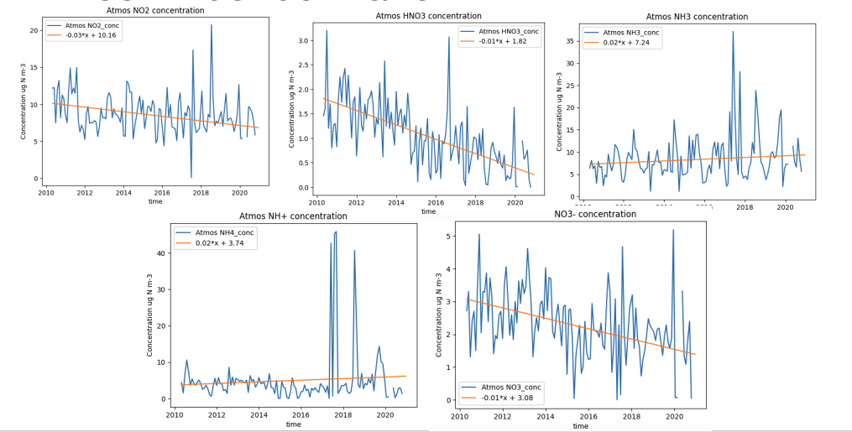
Fig. 1. Atmospheric nitrogen concentration from 2010 to 2020
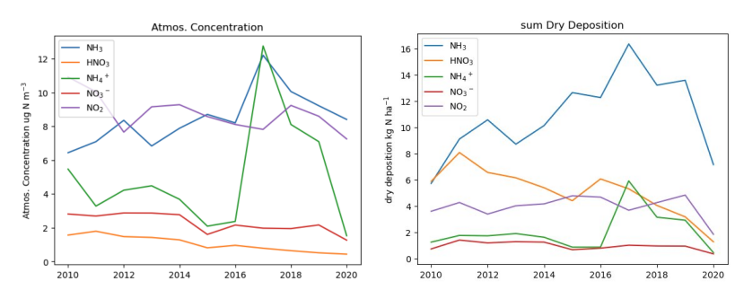
Fig. 2. Annual sum of concentration (left) and dry deposition (right)

All species showed nice seasonal variability for dry deposition, with peaks in the summer and troughs in the winter. Ammonium took almost half of the total nitrogen deposition (Fig. 2), it also showed the largest increase over the past decade. Ammonia showed a 25% increase compared to the deposition 10 years ago, with an increasing rate of 0.45 kg N ha⁻¹ per year. Both ammonia and ammonium showed an abnormal high in 2017, which is consistent with the high atmospheric concentration of the two species. Due to the fast increase of ammonia deposition, the proportion of ammonia in total N deposition increased from 33% to 50%. From Fig. 2 we can also see that the trend in atmospheric concentration is closely related to deposition, this may further suggest the strong influence of deposition on concentration. Relation between emission and deposition can be further calculated due to the nice linear relation between the two, each 1 Tg N per year of ammonia emitted can lead to 0.04 Tg N per year of nitrate deposition, and each 1 Tg S per year of sulfur dioxide can lead to 0.03 Tg N per year ammonium deposition (Zhu et al., 2022).

Given the relatively short atmospheric lifetime of NH₃ and NH₄⁺, this also implies substantial local or regional NH₃ sources in and around the GBA. We find tight correlations between annual mean atmospheric concentrations and dry deposition fluxes for individual species, highlighting that deposition at this site is largely concentration-driven. Coupled with the emission–deposition sensitivities reported by Zhu et al. (2022), this suggests that future changes in NH₃ and SO₂ emissions will continue to significantly modulate the magnitude and speciation of nitrogen deposition in the region.

Though observed PM2.5 concentration showed obvious seasonal variations (Fig. 3), with peaks in the winter and troughs in the summer. No doubt the concentration is decreasing, however, it’s hard to say if there’s any linear trend over the observed 10 years, especially in the summer. Organic matter is calculated using 1.4 times measured organic carbon, the figure showed organic matter took a major part in PM composition, other major components include sulfate, nitrite, and ammonium. The black line in the figure indicates the total measured PM2.5 concentration, sum of PM components showed nice consistency with measured total PM concentrations, with range error with 10%.
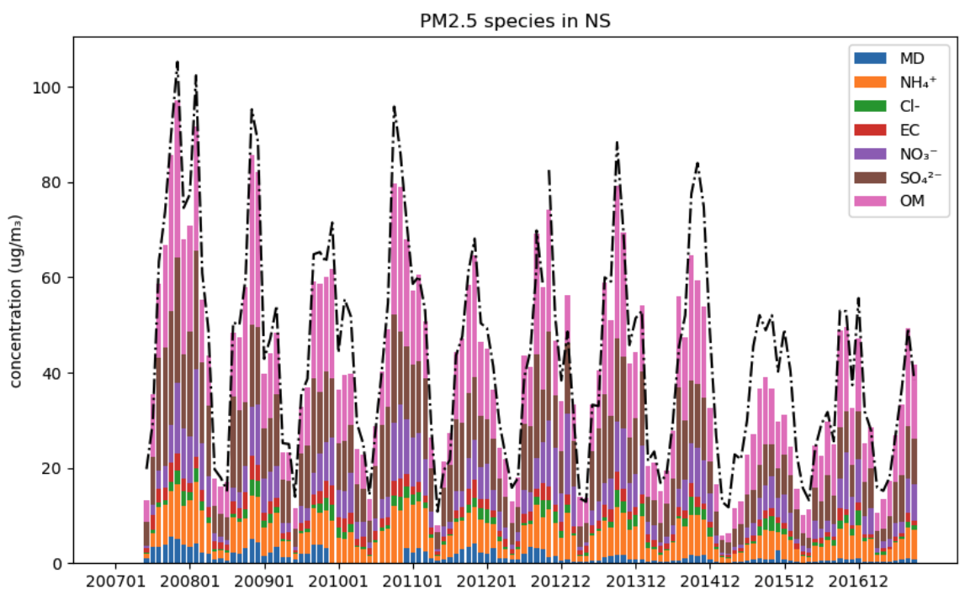
Fig. 3, monthly PM2.5 concentration and its constituents

Given the relatively short atmospheric lifetime of NH₃ and NH₄⁺, this also implies substantial local or regional NH₃ sources in and around the GBA. We find tight correlations between annual mean atmospheric concentrations and dry deposition fluxes for individual species, highlighting that deposition at this site is largely concentration-driven. Coupled with the emission–deposition sensitivities reported by Zhu et al. (2022), this suggests that future changes in NH₃ and SO₂ emissions will continue to significantly modulate the magnitude and speciation of nitrogen deposition in the region.
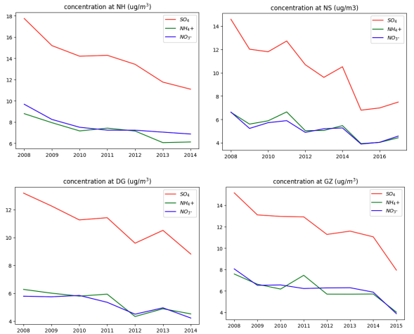
Fig. 4. SNA concentration in GBA at the four stations from Prof. Yu’s data

However, the current GCC model can hardly represent the observed results in PM composition. Fig. 5 showed monthly concentration for both observation and model in 2017, though the model worked well for the summer data, with error for total SNA small enough to neglect with error for total SNA small enough to neglect, modeled winter data is about 10% higher than the observation. This overestimation is especially significant in January and May. The model resulted a higher percentage of nitrate throughout the year, and a lower percentage for sulfate.
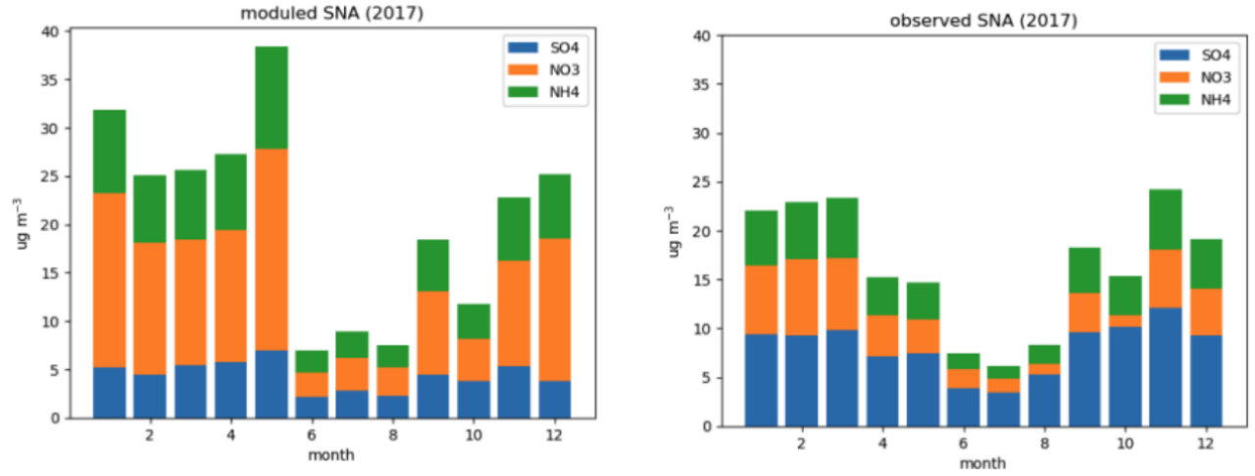
Fig. 5 modeled SNA concentration (left) and observed SNA concentration (right) in Guangzhou 2017

With the DLUO_WETDEP switch turned on, the model did show a better performance for some species (Fig. 6). The switch did not change much for NO₂ concentration, both cases modeled twice of the observation. Modeled ammonia is slightly better with the switch turned on, with roughly 10% improvement. The DLUO_WETDEP switch successfully reduced modeled NO₃⁻ from 15 times overestimate to 5.7 times overestimate, both cases showed nice seasonal variation agreement with the observation. Sulfate is one of the rather nicely reproduced species, turning on the switch reduced model results from 40% overestimate to 15% overestimate. The LUO switch also showed significant improvement for HNO₃, reducing the model result from over 240% overestimation, to only 150% overestimation. For organic carbon (OC), the refined model only showed an error less than 2% with the observation, compared to nearly 3 times overestimation and large anomalies previously.
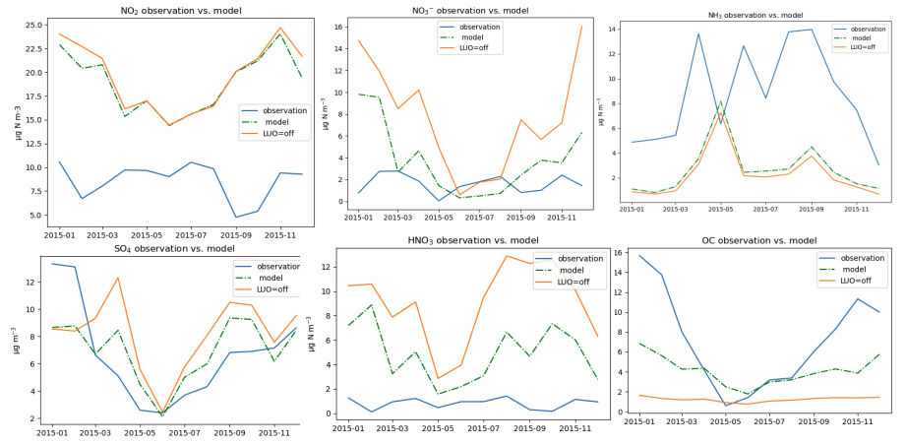
Fig. 6, species concentration for observation, default model, refined model

Particulate matter as a substance that actively interacts with people’s daily lives, it’s worth studying the mechanism behind the concentration and composition changes of the matter. Deposition, as a major removal pathway of the substances from the atmosphere, also a direct indicator of the total concentration, is one of the important factors in studying this mechanism. Though constently over estimating, the GC model did represnet the seasonal and spatial variations of PM_{2.5} and its components, by changing the deposition and emssision within the model, the modelled results can further be improved to match the observations. Combing observations with modelling enables identification and quantification of the drivers of PM variability.

References

Chow, W. S., Liao, K., Huang, X. H. H., Leung, K. F., Lau, A. K. H., & Yu, J. Z. (2022). Measurement report: The 10-year trend of PM2.5 major components and source tracers from 2008 to 2017 in an urban site of Hong Kong, China. Atmospheric Chemistry and Physics, 22, 11557–11577. https://doi.org/10.5194/acp-22-11557-2022

Gu, B., Ge, Y., Ren, Y., Xu, B., Luo, W., Jiang, H., Gu, B., & Chang, J. (2012, August 1). Atmospheric reactive nitrogen in China: Sources, recent trends, and damage costs. Environmental Science & Technology, 46(17), 9420–9427. (pubs.acs.org)

Keller, C. A., Long, M. S., Yantosca, R. M., Da Silva, A. M., Pawson, S., and Jacob, D. J.: HEMCO v1.0: a versatile, ESMF-compliant component for calculating emissions in atmospheric models, Geosci. Model Dev., 7, 1409-1417, 2014

Li, M., Liu, H., Geng, G. N., Hong, C. P., Liu, F., Song, Y., Tong, D., Zheng, B., Cui, H. Y., Man, H. Y., Zhang, Q., and He, K. B.: Anthropogenic emission inventories in China: a review, Natl. Sci. Rev., 4, 834-866, 2017.
Liu, L., Xu, W., Lu, X., Zhong, B., Guo, Y., Lu, X., Zhao, Y., He, W., Wang, S., Zhang, X., Liu, X., & Vitousek, P. (2022, March 28). Exploring global changes in agricultural ammonia emissions and their contribution to nitrogen deposition since 1980. Proceedings of the National Academy of Sciences, 119(14), e2121998119. https://doi.org/10.1073/pnas.2121998119
Liu, L., Wen, Z., Liu, S., Zhang, X., & Liu, X. (2024). Decline in atmospheric nitrogen deposition in China between 2010 and 2020. Nature Geoscience, 17, 733–736. https://doi.org/10.1038/s41561-024-01484-4

Luo, G., Yu, F., & Moch, J. M. (2020). Further improvement of wet process treatments in GEOS-Chem v12.6.0: impact on global distributions of aerosols and aerosol precursors. Geoscientific Model Development, 13, 2879–2903. https://doi.org/10.5194/gmd-13-2879-2020 (CC BY 4.0)

M. Liu,X. Huang,Y. Song,J. Tang,J. Cao,X. Zhang,Q. Zhang,S. Wang,T. Xu,L. Kang,X. Cai,H. Zhang,F. Yang,H. Wang,J.Z. Yu,A.K.H. Lau,L. He,X. Huang,L. Duan,[...]& T. Zhu, Ammonia emission control in China would mitigate haze pollution and nitrogen deposition, but worsen acid rain, Proc. Natl. Acad. Sci. U.S.A. 116 (16) 7760-7765, https://doi.org/10.1073/pnas.1814880116 (2019).

V. Shah,L. Jaeglé,J.A. Thornton,F.D. Lopez-Hilfiker,B.H. Lee,J.C. Schroder,P. Campuzano-Jost,J.L. Jimenez,H. Guo,A.P. Sullivan,R.J. Weber,J.R. Green,M.N. Fiddler,S. Bililign,T.L. Campos,M. Stell,A.J. Weinheimer,D.D. Montzka,& S.S. Brown, Chemical feedbacks weaken the wintertime response of particulate sulfate and nitrate to emissions reductions over the eastern United States, Proc. Natl. Acad. Sci. U.S.A. 115 (32) 8110-8115, https://doi.org/10.1073/pnas.1803295115 (2018).

Wang, X. (n.d.). China air quality historical data | Meteorological historical data | Beijing air quality historical data. Retrieved [Date], from https://quotsoft.net/air/

Xiao, Q., Geng, G., Liang, F., Wang, X., Lv, Z., Lei, Y., Huang, X., Zhang, Q., Liu, Y., & He, K. (2020, August). Changes in spatial patterns of PM2.5 pollution in China 2000–2018: Impact of clean air policies. Environment International.

Yan, F., Chen, W., Jia, S., Zhong, B., Yang, L., Mao, J., Chang, M., Shao, M., Yuan, B., Situ, S., Wang, X., Chen, D., & Wang, X. (2020). Stabilization for the secondary species contribution to PM2.5 in the Pearl River Delta (PRD) over the past decade, China: A meta-analysis. Atmospheric Environment, 242, 117817. https://doi.org/10.1016/j.atmosenv.2020.117817

Zhao, H., Chen, Z. & Li, C. Changes of PM_{2.5} and O₃ and their impact on human health in the Guangdong-Hong Kong-Macao Greater Bay Area. Sci Rep 14, 11190 (2024). https://doi.org/10.1038/s41598-024-62019-w

Zhu, H., Chen, Y., Zhao, Y., Zhang, L., Zhang, X., Zheng, B., Liu, L., Pan, Y., Xu, W., & Liu, X. (2022). The response of nitrogen deposition in China to recent and future changes in anthropogenic emissions. Journal of Geophysical Research: Atmospheres, https://doi.org/10.1029/2022JD037437

